  - State the problem – Find a problem that can be tested
  - Gather information – Research the problem you have found to try to create an experiment
  - Form a hypothesis – If then statement that predicts how an experiment you created will turn out.
  - Perform an Experiment – Test the hypothesis and collect data by making observations.
  - Analyze data – look at the data you have collected and organize it to be able to come to a conclusion
  - Conclusion – Accept or reject your hypothesis using the data collected during the experiment.
- Beaker
- Meter Stick/ Ruler
- Triple beam balance
- Digital balance
- Thermometer
- Gloves
- Goggles
- Lab Coat
- Pipette
- Graduated Cylinders
Food: no food or water should be brought to lab and especially eaten or consumed
Accident: all accidents should be reported to the teacher immediately
Dress Code: Do not wear baggy clothing and all hair and items that do hang should be pulled up and removed from any items being used for lab
- Data – Information you collect when you observe something
- Hypothesis - suggested answer to a question or problem
- Control – experiment in which all the conditions except one are kept constant
- Variable – anything that can affect the outcome of an experiment
- Theory – set of hypothesis that have been supported by testing over and over again.
- Scientific method – Method used by scientist in order to solve problems and create experiment for research.
- Law – is a statement based on repeated experimental observations that describes some aspect of the universe
- Meniscus – curve at the surface of a liquid in a thin tube.
- UNIT - amount used to measure something
- Model - tool scientist use to represent an object or process

  - Atmosphere – The envelope of gases that surround the earth
  - Hydrosphere - part of earth this is water.
  - Lithosphere - The solid part of the earth.
  - Biosphere - The part of the lithosphere, hydrosphere and atmosphere that is occupied by living organisms
- You may draw this on the back of the study guide.
  - 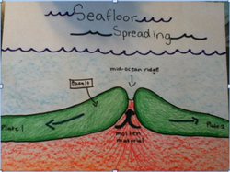
  - 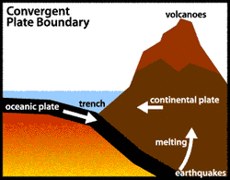
  - 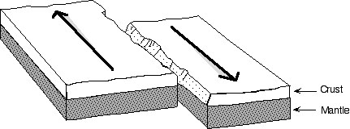

  - Hot spot – place where magma reaches the surface of a tectonic plate
  - Continental drift - theory that the continents were at one or more time a single giant landmass that later broke apart and drifted to the positions they are in today.
  - Pangaea – The single giant landmass, or continent , that later broke apart
  - Convection current - movement of a gas or liquid caused by changes in temperature
  - Plate boundary – place where two plates meet
  - Rift valley – flat area between two ridges that is formed by spreading plates
  - Seafloor spreading – process that forms new seafloor.
  - Subduction zone - place where old oceanic crust is forced back down into a n ocean trench.
  - Theory of plate tectonics – Theory that earth’s crust is broken into plates that float on the upper part of the mantle.
  - Trench – underwater landform resembling a canyon.
  - Mid ocean ridge - underwater landform resembling a mountain on land.
- Pangaea
- 4.6 billion
- Trenches
- Mountain is formed
- Earthquake
- Mesosaurus
- Africa
- Oceanic crust
- Mid ocean ridges is where new oceanic crust is being made by the process of sea-floor spreading and subductions zones allows for the crust to be forced back down into the mantle and be recycled. Since this is true the earth is able to remain the same size as there is always new crust being made and old crust being recycled.
- The san Andrea’s fault was created by the pressure that affects the crust. This pressure comes from the convection currents of magma within the mantle. High pressure causes rocks to break and move. Fractured rock layers that move are known as faults and ones that slide past each other are familiarized with frequent earthquake activity. This is how the san Andrea’s fault is explained by the theory of plate tectonics. The Earth’s crust is broken into plates and float on the mantle for the same reason.
- Pressure
- Sharp and pointy and high elevation
- Mountain system
- Lava

  - Anticline – Upward Fold in rock
  - Syncline- Downward fold in rock
  - Fracture – Break in rock
  - Fault – Break in earth’s crust where movement occurs
  - Volcanism – any movement of magma within the earth’s crust
  - Lava – molten rock once it has reached the surface of earth’s crust
  - Volcano – vent and the volcanic material around it
  - Crater – pit at the top of a volcano
  - Caldera- large hole that forms when the roof of a magma dome has collapsed back in on itself
  - Shield volcano – volcanic cone made up of layers of hardened rock – that oozed for miles
  - Cinder cone – volcanic cone made up of rock particles and dust and ash
  - Composite cone - (STRATOVOLCANO) volcanic cone made up of alternating layers of hardened rock and rock particles dust and ash.
- Anticline-upward fold syncline-downward fold
- Fracture-crack fault-crack with movement
- Folded mountain-layers are squeezed fault block-chunks of rock are pushed together
- Convergent-comes together divergent-pulls apart
- Normal-vertical strike slip-horizontal
- Old mountain-rounded, broad young mountain-steep, jagged
- Plain-flat area right above sea level plateau-elevated flat area
- Volcanic-formed by eruptions dome-folded
- Subduction zone-convergent mid ocean ridge-divergent
- Inner core-solid outer core-liquid

