Chapter 11 Study Guide Name ____________________________________________________________
Parent signature _______________________________________________
Interpreting Diagrams Identify the kind of local wind shown in each diagram. Choose from the following terms: land breeze, sea breeze, mountain breeze, valley breeze, summer monsoon, and winter monsoon.
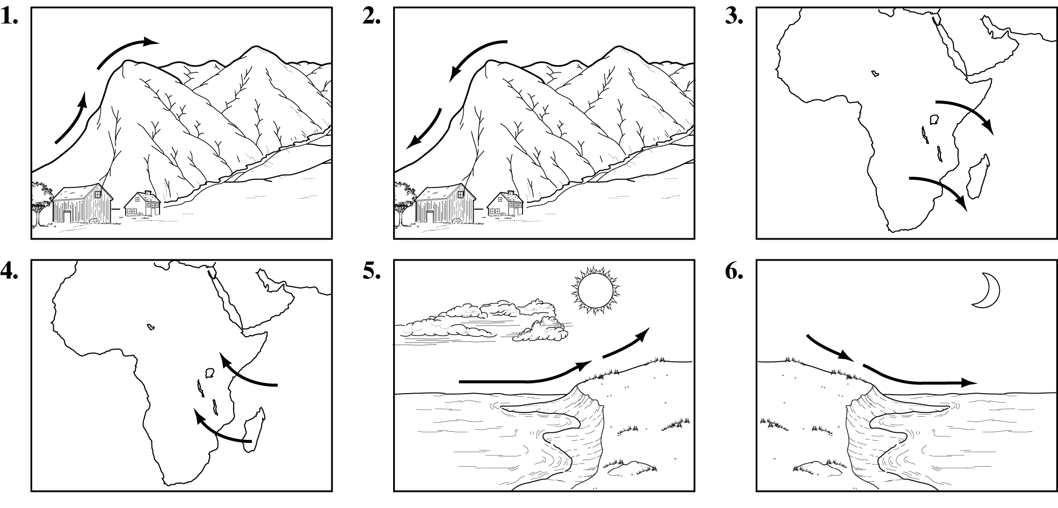
1.  2.  3. | 4.  5.  6.
Write the term or phrase that best completes each statement.
1. Matter is anything that has mass and ____________________________________________________.

2. The gas that makes up most of air is _____________________________________________________.

3. The layer of the atmosphere closest to Earth’s surface is the
________________________________________________.

4. The layer of the atmosphere that is helpful to communications is the
________________________________________________.

5. The movement of energy through empty space is called _______________________________.

6. Heat moves through solids by ___________________________________________________________.

7. Heat moves through liquids and gases by _______________________________________________.

8. Air pressure at sea level is about _________________________________________________________.

9. As water vapor in the air increases, air pressure _______________________________________.

10. Evangelista Torricelli invented the ______________________________________________________.

11. Air pressure is measured in this unit ____________________________________________________.

12. Standard air pressure is equal to _________________________________________________________.

13. Regions of cold, heavy air are called _____________________________________________________.
14. As cool air moves under warm air, it pushes the warm air ____________________________.

15. A breeze that blows from the ocean toward the land is a ______________________________.

16. A wind that changes direction with the season is a _____________________________________.

17. Wind speed is measured with an _________________________________________________________.

18. A wind that blows from the east toward the west is ____________________________________.

19. An up-and-down movement of air is _____________________________________________________.

20. Wind direction is measured with a ______________________________________________________.
21.HYPOTHESIZE: Why does weather take place only in the troposphere?

22. ANALYZE: Is Earth’s atmosphere warmed by radiation from the Sun or radiation from Earth’s surface? Explain.

