Chapter 11 Study Guide Name ____________________________________________________________
Parent signature _______________________________________________
Interpreting Diagrams Identify the kind of local wind shown in each diagram. Choose from the following terms: land breeze, sea breeze, mountain breeze, valley breeze, summer monsoon, and winter monsoon.
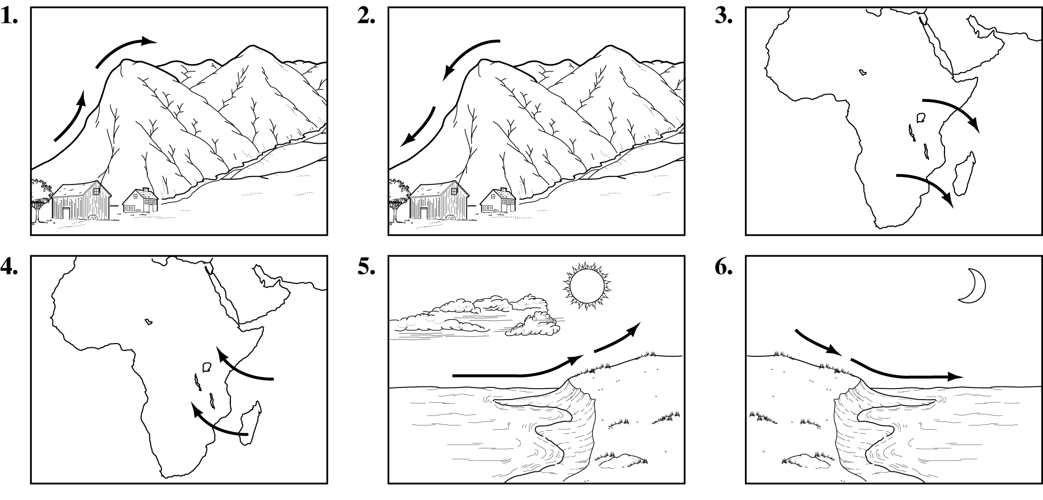
1. valley breeze  2. mountain breeze  3. winter monsoon | 4. summer monsoon  5. sea breeze  6. land breeze
Write the term or phrase that best completes each statement.
1. Matter is anything that has mass and volume

2. The gas that makes up most of air is _nitrogen.

3. The layer of the atmosphere closest to Earth’s surface is the
troposphere.

4. The layer of the atmosphere that is helpful to communications is the
Ionosphere.

5. The movement of energy through empty space is called radiation

6. Heat moves through solids by conduction

7. Heat moves through liquids and gases by convection.

8. Air pressure at sea level is about ____10 N/cm_____________________________.

9. As water vapor in the air increases, air pressure decreases

10. Evangelista Torricelli invented the __mercury barometer_.

11. Air pressure is measured in this unit millimeters, millibars, or N/cm

12. Standard air pressure is equal to ___1,013.20 mb____.

13. Regions of cold, heavy air are called ________highs_____________________________________________.
14. As cool air moves under warm air, it pushes the warm air _____up .

15. A breeze that blows from the ocean toward the land is a sea breeze

16. A wind that changes direction with the season is a monsoon

17. Wind speed is measured with an anemometer__.

18. A wind that blows from the east toward the west is east wind

19. An up-and-down movement of air is an air current.

20. Wind direction is measured with a wind vane_.
21.HYPOTHESIZE: Why does weather take place only in the troposphere?
The troposphere is the only layer of the atmosphere that has winds, water vapor, and
variations in temperature. All of these conditions are necessary for weather.
22. ANALYZE: Is Earth’s atmosphere warmed by radiation from the Sun or radiation from
Earth’s surface? Explain. Earth’s atmosphere is mostly warmed by Earth’s radiation. The
Sun’s radiation passes through the atmosphere and warms Earth. Earth’s radiation then
warms the atmosphere.

