.

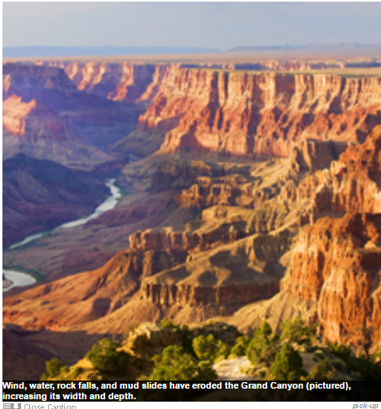
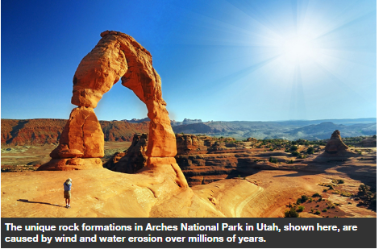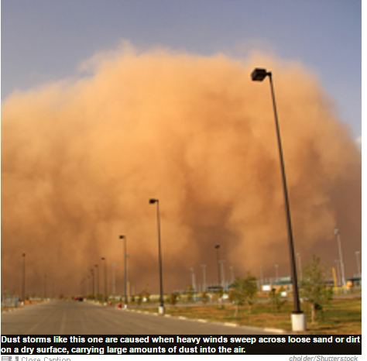

Despite their vastly different appearances, the Grand Canyon, the fjords of Norway, the sand dunes of the Sahara, and the white beaches of Malibu, California, all share common origins. These diverse landforms, and many more, were created by one of nature's most powerful forces—erosion.
Erosion, simply put, is the wearing away and removal of soil, rock debris, and other material from Earth's surface, and its transportation to new places. The forces behind erosion are many and varied. The most significant is moving water, especially that of rivers. The Colorado River, for example, slowly carved out the magnificent Grand Canyon. The pounding ocean surf is another powerful water sculptor. The beautiful coves of La Jolla, California, and the dazzling white cliffs of Dover, England, are among the many striking creations of the ocean. Wind constitutes another powerful erosive force, as do glaciers. Such forces continually shape and reshape the surface of Earth and the many landforms upon it.
WEATHERING
Erosion begins with the process of weathering, the chemical decay and physical breakdown of solid rock. Weathering reduces rock beds and large boulders into rock debris, soil particles, and sand.
An important aspect of weathering is the speed at which it takes place. Given enough time, almost any exposed rock will eventually be worn away. Whether this process takes months, years, centuries, or millennia depends on several conditions.
An obvious factor is the nature of the rock—its hardness, texture, and chemical solubility. Rocks composed of hard minerals such as quartz crystals are remarkably resistant to weathering and break down quite slowly. In contrast, soft limestone weathers quickly. Indeed, it will completely dissolve in weakly acidic water, such as rain. The rapid weathering and erosion of underground limestone has created the world's most magnificent caverns.
Much harder rocks can be quite vulnerable to weathering if they are marred with fractures and joints. Such cracks provide an entry place for water, bacteria, and plant roots, which can break the rock apart from within. Water, for example, expands when it freezes. As a result, water that percolates into cracks in a rock will act like a wedge if it freezes. This pressure can crack the rock further, exposing more of its surface to the forces of weathering.
Rocks that are composed of large, coarse grains tend to be more susceptible to weathering than are fine-grained rocks because the size of air spaces between the grains increases with the size of the grains.
Climate is another important factor in erosion and the preliminary process of weathering. Hot and humid climates, for example, accelerate many of the chemical reactions that lead to weathering. Such weather conditions can stimulate the chemical conversion of the mineral feldspar into the soft white clay known as kaolinite, which is more vulnerable to erosion.
Another factor that can speed erosion is the presence of water, a good catalyst for many chemical reactions. Heat energy often provides fuel for these reactions. In the absence of water, chemical weathering slows tremendously. This fact explains the amazing endurance of the pyramids and other ancient monuments located in the bone-dry climate of the Egyptian desert.
RIVER EROSION
Rivers are truly remarkable in their ability to erode and sculpt Earth. In fact, many geologists believe that if Earth's surface were not periodically lifted by techtonic and volcanic activity, rivers would have lowered the continents to sea level ages ago. Each century, the world's rivers carry away enough sediment to cover the entire planet's surface with a layer nearly 0.5 inch (1.3 centimeters) thick. (The majority of this sediment is dumped into the world's oceans and inland seas.) The Colorado River alone can carry some 500,000 tons of sediment each day.
The sheer movement of water in a river continually removes soil and rocks from its banks and bottom. Once suspended in the water, the rocks and soil add to the scouring action of the river. River erosion can ultimately etch out valleys and steep-walled canyons, and wear mountains down to their foundations; it can also carve minor landforms such as twisting meanders and oxbow lakes. When a river eventually deposits its load of sediment, the results are sandbars, floodplains, and deltas.
WIND EROSION
In arid regions of the world, there is little rainwater and few rivers. Wind erosion thus plays a more important role in shaping the land.
Deflation is the winnowing away and transport of dry, loose material such as salt, silt, and clay by the wind. Deflation reaches its extreme in deserts. When strong desert winds lift away all small particles on the ground, a virtual armor of large rock fragments known as desert pavement is left behind. Desert pavement is smooth, compact, and highly resistant to erosion. It is also completely barren, providing no soil in which a seed or root can take hold.
Once the desert wind is filled with sand, it becomes an even more powerful erosive force. The airborne particles literally sandblast all of the rocks, stones, and other objects in their path. These forces likely sculpted the remarkable buttes of Monument Valley, Arizona.
Wind erosion was also responsible for one of the great disasters of the 20th century: the Dust Bowl of the 1930s. Before World War I, grassland covered much of the Great Plains of the United States. In the 1920s, however, a new generation of farmers plowed under millions of acres of that grassland, largely to make room for wheat cultivation. As a result, when a severe drought struck southeastern Colorado, southwestern Kansas, the panhandles of Texas and Oklahoma, and northeastern New Mexico in the early 1930s, there were no native grasses to anchor the topsoil. The wind lifted the dry soil and carried it away in great black clouds.
The Dust Bowl saw the ruin of thousands of farms. The Plains area recovered—partially—only after windbreaks of vegetation were planted to stave off further erosion.
GLACIAL EROSION
Unlike river and wind erosion, the process of glacial erosion is difficult to view in action. It occurs slowly over hundreds of years. Most of the glacier sculpting seen today was completed in prehistoric times, when massive continental glaciers swept over much of the Northern Hemisphere.
The products of these ancient glaciers can be seen around the world. The great U-shaped valleys of Yosemite, California, the pointed peaks of the European Alps, and the broad basins of the Great Lakes were all shaped by glaciers. The fjords of Norway are glacial valleys that were cut below the current sea level and eventually filled with water.
Glacial erosion occurs in two ways. First, as glaciers advance, they pick up debris and pluck rocks out of the soil. Then, once embedded in the glacial ice, these objects scrape and abrade rock beds at the bottom and sides of the advancing glacier. As glaciers move down mountains, they scoop out valleys into a distinctive bowled shape. They also leave characteristic scratch marks, called glacial striae, on the bedrock and valley sides.
When a glacier finally stops moving, it deposits its accumulated debris at its leading edge. Retreating glaciers also leave scattered boulders and other debris—often in unusual or precarious locations.

WAVE EROSION
Ocean waves erode the coastline in several ways. Most obviously, they do so by the sheer pressure of waves breaking and pounding against beaches and rocky cliffs. Waves also abrade the shore by raking it with suspended pebbles and sand. Among the products of wave erosion are sea caves and benches at the base of rocky cliffs. The rock fragments pounded away from sea cliffs are further pulverized into sand, and deposited elsewhere.
Given enough time, waves can wear away entire islands. For example, oceanographers recently discovered a chain of extinct undersea volcanoes, dubbed the Foundation Seamounts, in the South Pacific near Easter Island. The tops of these seamounts now lie several hundred feet beneath the water's surface. But some are flat-topped and covered with rocks and dead coral reefs—evidence that they once rose above the surface. Scientists believe that extensive wave erosion ground them back into the sea.
HUMAN EROSION
Erosion is very much a natural process, but one that has become greatly influenced by human activity.
One of the earliest examples of human-caused erosion was due to the burning of vegetation by migrant prehistoric farmers tens of thousands of years ago. Such burning may have led to the development of some of the world's major grasslands and prairies. Unfortunately, the deserts of the Mediterranean region may have also resulted from human deforestation.
The ancient Egyptians and other early civilizations also dammed rivers for irrigation purposes. This often led to the buildup of sediment within the rivers, with the end result being increased flooding and erosion.
Today roughly two-thirds of Earth's surface is affected by soil erosion, much of it spurred by human activity. Humans are only now learning about the consequences of their actions. The breakwaters and jetties built to protect harbors, for example, often interfere with coastal currents in a way that traps sand within a harbor or deprives nearby beaches of their sand supply. Engineers are now taking these effects into consideration when placing and building such structures.
Even the construction of roads and buildings can change the way erosion shapes the land. Roads and other paved surfaces, for example, prevent water from seeping into the soil. This increases both the speed and volume of runoff from rain and overflowing rivers—again increasing erosion.
Industrial activity has also produced erosive agents that are unique to modern times. Factory emissions are often rich in sulfuric acid and other chemicals that collect in rain clouds. The resulting acid rain is much more corrosive than ordinary rain, accelerating the weathering of rocks and harming the essential vegetation needed to hold soil in place. Hopefully, such destructive forces can be better controlled in the future with a greater understanding of erosion and a heightened awareness of humanity's ability to alter its course.
Kathy Svitil

