Name _________________________________________________
Parent signature __________________________________________
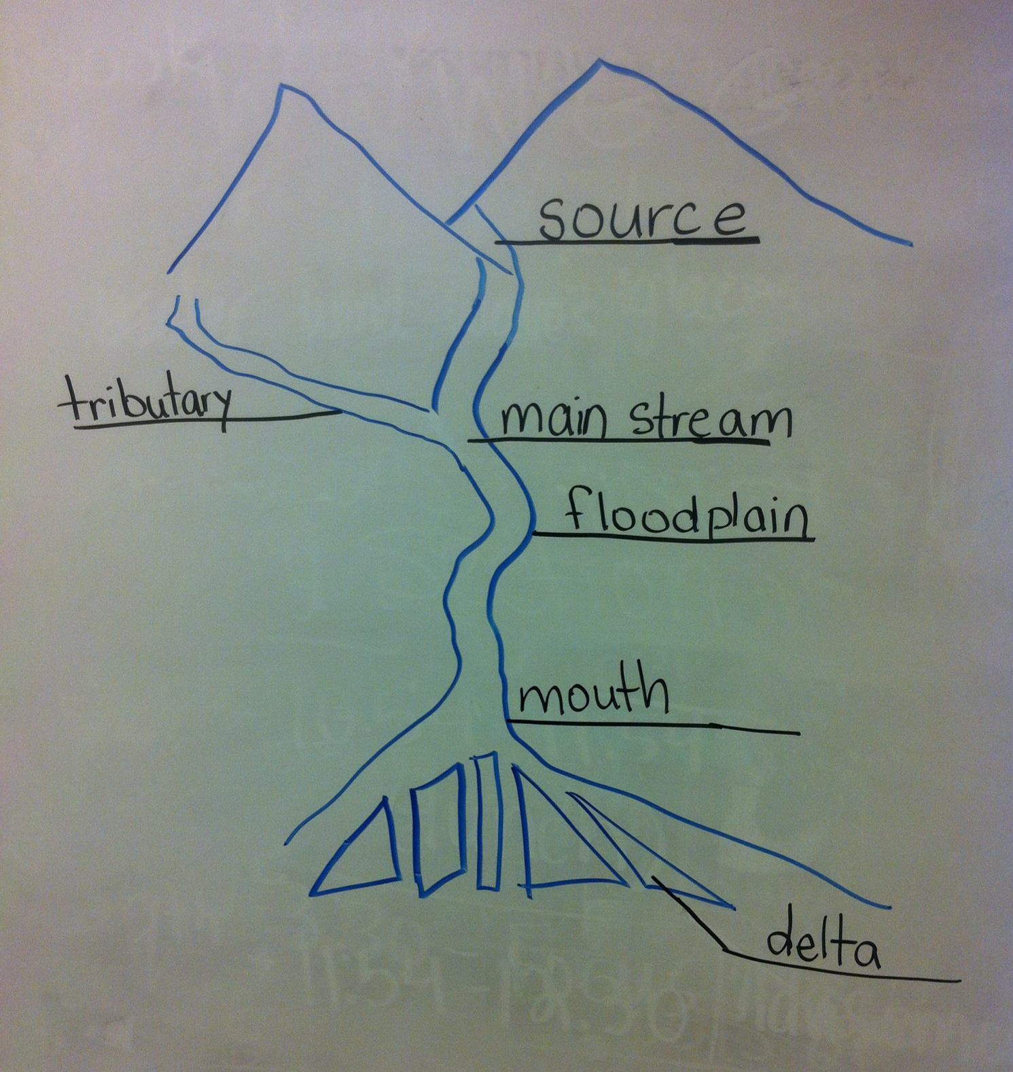
Date of test Friday, January 13th
Chapter 8 study guide
- Draw a river and label the following parts: mouth, tributary, source,
floodplain, main stream, delta
- The process by which weathered materials are moved is called erosion_
- What agent of erosion formed the Grand Canyon? ___running water______
- What are the 5 agents of erosion? Water, waves, wind, gravity, glaciers
- What are 2 examples of fast mass erosion? landslide and __mudflow
- What are 2 examples of slow mass erosion? earthflow_ and _creep__
- The removal of loose materials from earth’s surface by wind is deflation
- The side of a sand dune with a steep slope is called _slipface_____.
- Name 3 types of landforms caused by glaciers moraines, kettle lakes, drumlins, u-shaped valley
- Most erosion begins with what agent of erosion? gravity
- When did the last ice age end? 11,000_ years ago
- The _mouth of a river is where it ends.
- Glaciers that form in mountains and move slowly downhill through valleys are called valley glaciers_.
- Loose material deposited by a glacier is called _till__.
- A boulder left behind by a retreating glacier is called an erratic (hint: think about Clarence )
- A __sea stack forms when the top of a sea arch falls in to the water.
- A long offshore underwater deposit of sand is called a __sand bar____________.
- __Loess is wind-blown dust.
- Sinkholes and caverns are features of Karst__ topography.
- Caves and sinkholes form due to a combination of __limestone__ and the __carbonic acid in the rain.
- A sinkhole lake forms when a sinkhole _fills with water__________________.
- A long, narrow deposit of sand that is connected at one end to the shore is a _spit .
- What shape valley do glaciers scrape out? __u-shaped_
RACER: (attach on a separate sheet of paper)
- Why might the floodplain of a river be a good location for a farm? Why might it be a poor location for a farm?
-good-water for crops
-poor-flooding can ruin crops
- What causes a glacier to move?
-weight of the ice and snow compacts the lower layers and gravity pulls it down the incline

