Name ___________________________ Date ____________________
Class period ______________________

IMAX HUBBLE
video viewing guide
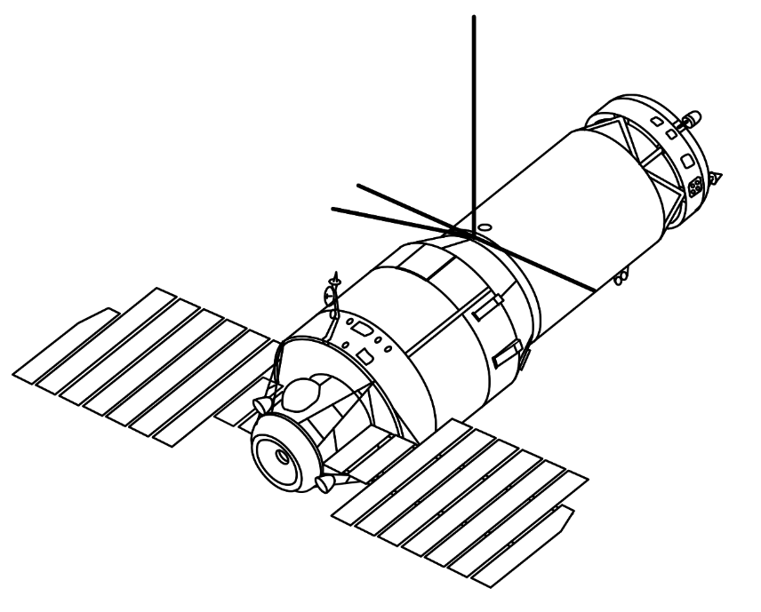

- What is this the last chance to do? _________________________________________
- How long did the Hubble take to build? _____ How many people built it? _________
- What needed to be repaired on the Hubble? _________________________________
- Name one thing the Hubble “saw” that hadn’t been seen before. ________________
- What is a star nursery? __________________________________________________
- Why might an infant solar system (referred to as “tadpoles”) not eventually turn into a full solar system? _____________________________________________________
- What will happen if Hubble is maintained and repaired regularly? _____________________________________________________________________
- When will the final mission be? ___________________________________________
- Why is a pool used in training for the Hubble Space Walk? _____________________________________________________________________
- What type of space vehicle took the team to the Hubble? ______________________

