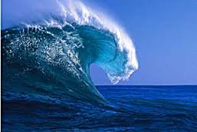
Oceans Guided Notes

Name_________________________________ Class ________________________________

The Salty Sea
- The water in earth's oceans is _______________________ water.
- The amount of dissolved __________________ in ocean water is _______________________.
- _____________ water from rivers, precipitation, and melting glaciers ______________________ ocean salinity.
- During the ________________, water _________________________ from the _________________ of the ocean, leaving behind dissolved salts.
-This raises _________________________.

Salinity varies more at the surface than in deep ocean water. Why? ___________________________________________________________________________________________
What is salinity? ______________________________________________________________________

Temperature Layers
- There are _______________ layers of the oceans. These layers are
based on __________________.
- surface
- thermocline Draw the ocean levels
- deep
- SURFACE LAYER
  - Heat from ________ warms the ocean water
  - Surface layer is from _______-________ meters deep
  - ____________ and ____________ keep the water in the surface layer well mixed.
- THERMOCLINE LAYER
  - Lies below the ________________ layer
  - Temperature ______________________ sharply with depth
  - ___________ than the surface
- DEEP LAYER
  - ___________________ layer
  - Temperatures are usually ______________________ 5 degrees Celsius
What are the 3 temperature layers of the ocean? ________________________________
Which is the warmest? ______________________________ Why?__________________________
DESALINATION-the removing of _______________ from ocean water so that is suitable for drinking. Many countries have desalination plants in which ______________ is ___________________, leaving the remaining __________________ water.
OCEAN CURRENTS-stream of __________ flowing in the oceans
**think of a running ___________________ in the ocean
- types of currents:
- Density current-stream of ____________________ that moves _______ and _____________ in the ocean depths.
  - Differences in density can cause currents to move up and down in the ocean depths
- Surface Current-caused by _________________
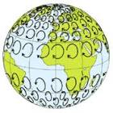
Coriolis Effect-bending of _______________________ winds and ocean ___________________ nu Earth’s rotation

