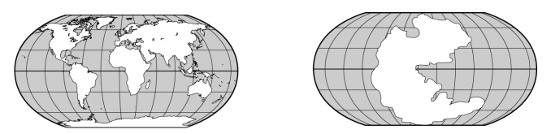
- What does the map on the left show? ____________________________________________________________
- What is the name of the giant landmass on the map on the right? ______________________________________
- Who first stated the theory of continental drift? ____________________________________________________
- What does the theory of continental drift state? ______________________________________________________________________________________________________________________________________________________________________________________
- What evidence shown on the map on the left is used to support the theory of continental drift? ___________________________________________________________________________________________
- How many continents are on earth today? __________________
- Earth’s large landmasses are ____________________________
- The fossil animal that is used to support the idea of continental drift is _________________________________
- The crust that makes up the ocean floor is the ________________________________________
- New seafloor is formed by ____________________________________________________
- Underwater mountain ranges are called _____________________________________________
- The dep crack running down the center of the mid-atlantic ridge is a ______________________________
- A deep canyon on the ocean floor is a _____________________________________
- The place in which old crust is pushed down into a trench is a _____________________________________
- Scientists estimate that Earth’s age is about __________________________________ years old
- The oldest rocks found on the ocean floor are about ___________________________ years old
- Many trenches are located along the _______________________________________
- Scientists use the magnetic properties of some minerals as evidence of _______________________________
- The idea that earth’s crust is made up of separate plates that float on the upper mantle is the theory of _________________________________________________
- Scientists have identified about _____________________ tectonic plates
- The movement of a gas or liquid caused by differences in temperature is a ______________________________.
- Two plates move toward each other at a ______________________________ boundary.
- Features formed at divergent boundaries are _____________________ valleys.
- Scientists think that the movement of earth’s tectonic plates are caused by convection currents in the _____________________________________.
- The movement of tectonic plates at a fault is a cause of _______________________________.
- The Hawaiian islands formed when the Pacific plate moved over a ______________________________.
Explain: How do fossils help support the theory of continental drift? ______________________________________________________________________________________________________________________________________________________________________________________________________________________________________________________________________________________________________
Compare: What is the difference between a convergent boundary between an oceanic plate and a continental plate and a convergent boundary between 2 continental plates? ______________________________________________________________________________________________________________________________________________________________________________________________________________________________________________________________________________________________________
Draw and label each picture from your plate tectonics “Draw with Mrs. Wolfe” booklet.

.

