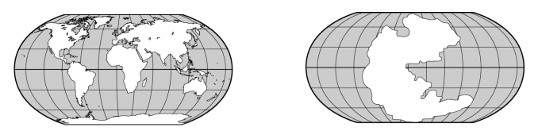
- What does the map on the left show? ___the continents as they are positioned today______
- What is the name of the giant landmass on the map on the right? __Pangaea___
- Who first stated the theory of continental drift? _Alfred Wegener__
- What does the theory of continental drift state? _that the continents were once a part of a giant landmass that broke apart and drifted to their current positions
- What evidence shown on the map on the left is used to support the theory of continental drift? the shapes of the continents seem to fit together like puzzle pieces
- How many continents are on earth today? __7_
- Earth’s large landmasses are continents
- The fossil animal that is used to support the idea of continental drift is _Mesosaurus___
- The crust that makes up the ocean floor is the _oceanic crust____
- New seafloor is formed by seafloor spreading
- Underwater mountain ranges are called _mid-ocean ridge
- The deep crack running down the center of the mid-atlantic ridge is a rift.
- A deep canyon on the ocean floor is a _trench_
- The place in which old crust is pushed down into a trench is a subduction zone
- Scientists estimate that Earth’s age is about 4.6 billion years old
- The oldest rocks found on the ocean floor are about 160 million years old
- Many trenches are located along the Pacific Ring of Fire
- Scientists use the magnetic properties of some minerals as evidence of seafloor spreading
- The idea that earth’s crust is made up of separate plates that float on the upper mantle is the theory of plate tectonics
- Scientists have identified about 21 tectonic plates
- The movement of a gas or liquid caused by differences in temperature is a convection current
- Two plates move toward each other at a convergent boundary.
- Features formed at divergent boundaries are rift valleys.
- Scientists think that the movement of earth’s tectonic plates are caused by convection currents in the mantle
- The movement of tectonic plates at a fault is a cause of earthquakes
- The Hawaiian islands formed when the Pacific plate moved over a hot spot
Explain: How do fossils help support the theory of continental drift? The fact that fossils of the freshwater animal Mesosaurus have been found in Africa and South America suggests that at the time Mesosaurus lived, Africa and South America were joined as one landmass that eventually drifted apart.
Compare: What is the difference between a convergent boundary between an oceanic plate and a continental plate and a convergent boundary between 2 continental plates? At a convergent boundary between an oceanic plate and a continental plate, a subduction zone occurs because the denser oceanic crust slides under the continental crust. At a convergent boundary between 2 continental plates, the plates crumple upward and mountains are sometimes formed.
Draw and label each picture from your plate tectonics “Draw with Mrs. Wolfe” booklet.

.

